**Camera** **Calibration**

**Setting up Calibration Grid User Frame**

1. While the robot is in STEP mode(press STEP button on TP, indicator should be yellow in status bar on top of TP screen), run the JR_Calibration program on the teach pendent. Stop at Point 1. The robot should be over the grid.

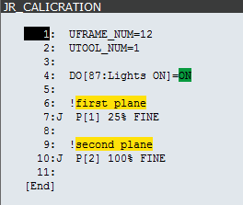

1. With the robot and grid in position, you can run the Automatic Grid Frame Set function on the robot teach pendent.
   1. Menu
   2. IRVision
   3. Vision Utilities
   4. Automatic Grid Frame Set
   5. Detail (F3)
   6. Arrow down the Start Position, and press Record (F4)
   7. Enter the values shown below for items 1-12 (Note: these values are just starting points, they may need to be adjusted)

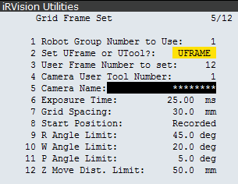

1. Once the starting position has been recorded, and all values set, you can execute the grid frame set function. CAUTION, Robot is going to move once you start!
   1. Make sure Start Position is not highlighted.
   2. While holding the enable switch and shift, press execute. (FCTN Abort All)

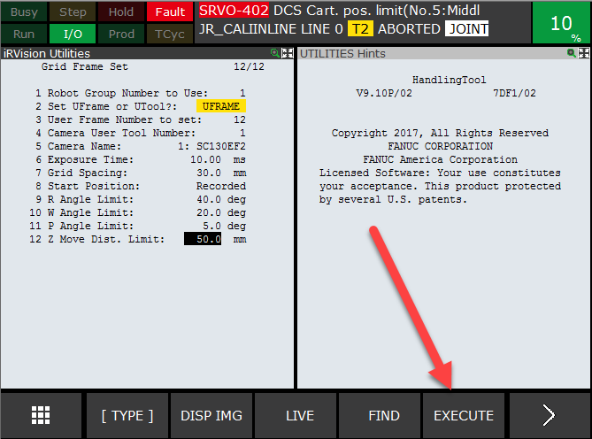

* 1. Once complete, the user frame will be taught for the Calibration Grid.

**Camera Calibration**

1. While in STEP mode, Re-Run the JR_Calibration program on the teach pendent. Stop at Point 1.
2. Using Internet Explorer, open Vision Setup and select TOTECAMERA program.

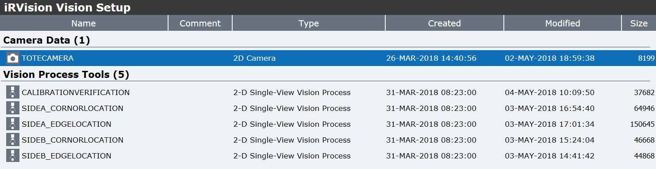

1. On the Calibration Tab, SNAP an image, then select FIND for 1st PLANE.

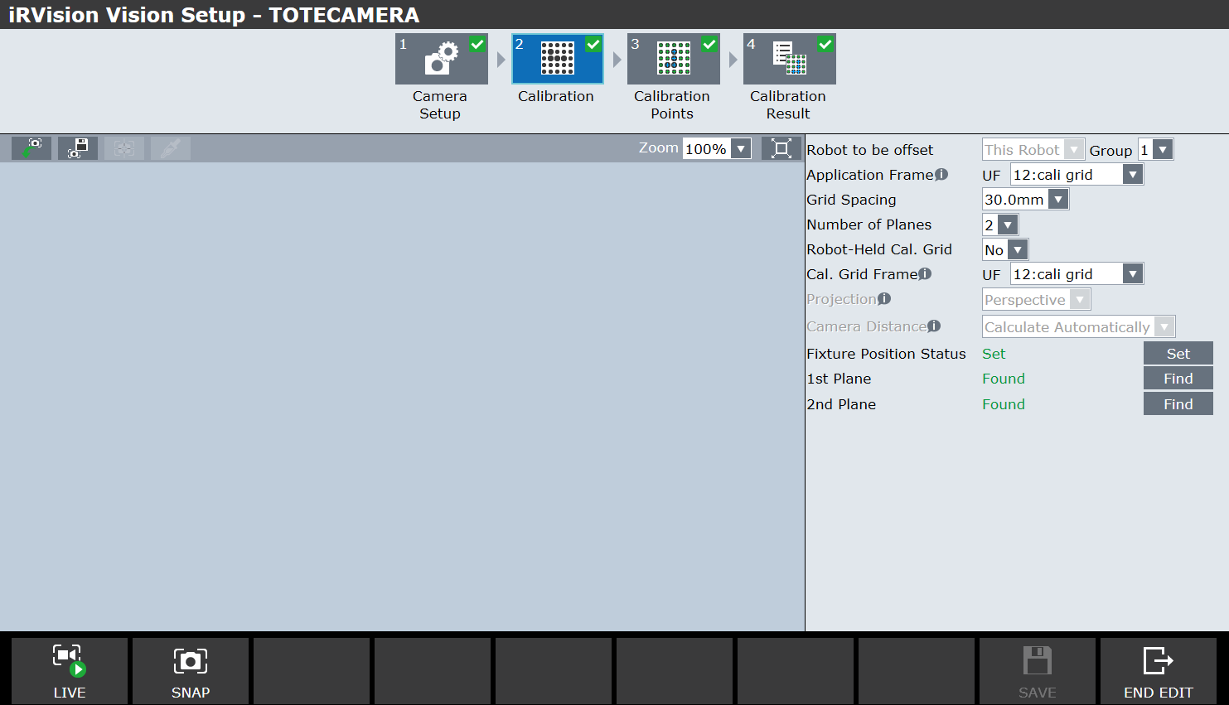

1. Using the Teach Pendent, STEP to point 2.
2. On the Calibration Tab, SNAP an image, then select FIND for 2nd PLANE.
3. Select SET.
4. SAVE
5. END EDIT

**Camera Calibration Check**

1. While in STEP mode, Run the CalibrationCheck program on the teach pendent. Stop after the vision lights turn on.
2. Using Internet Explorer, open Vision Setup and select CalibrationVerification program.



* 1. Click “Snap + Find”
  2. Train this L-shaped dot pattern
     1. Select “GPM Locator Tool”
     2. Press “teach”

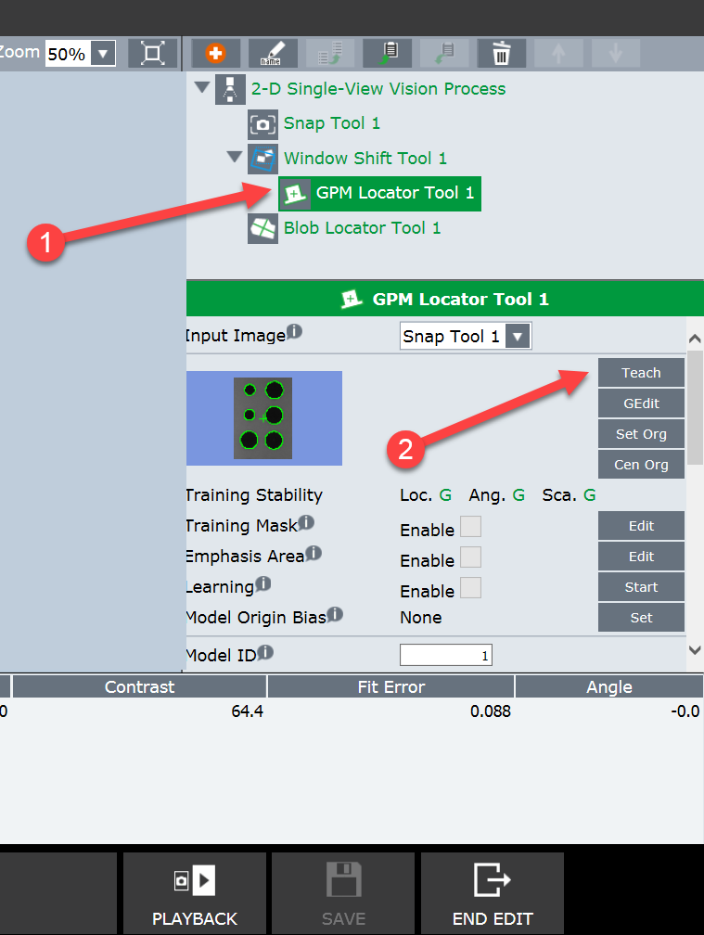

* 1. Expand the box around these 6 dots, then hit OK

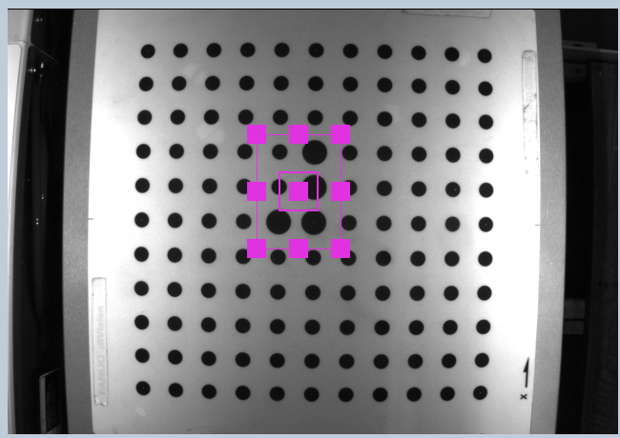

* 1. Test it by hitting SNAP+FIND multiple times, make sure it finds it (we don’t care about the actual values)
  2. Adjust the search window if necessary, should be similar to this pic

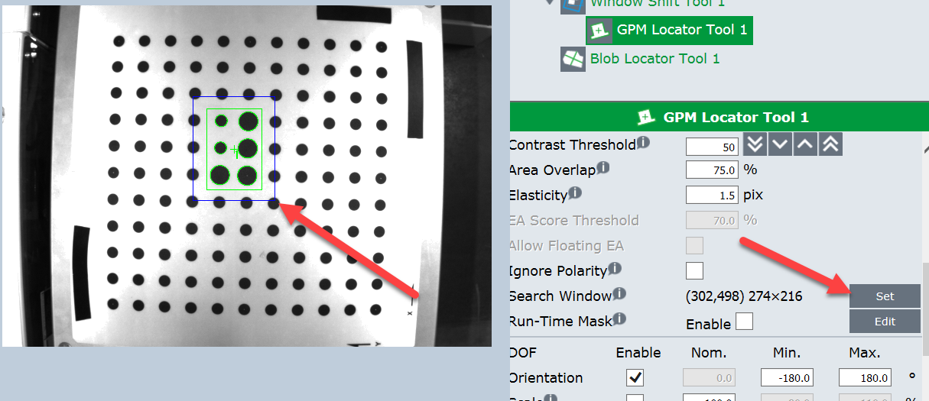

* 1. Retrain the single dot:
     1. Select “Blob Locator Tool 1”
     2. Select “Teach”, draw the box around the single dot, then hit OK

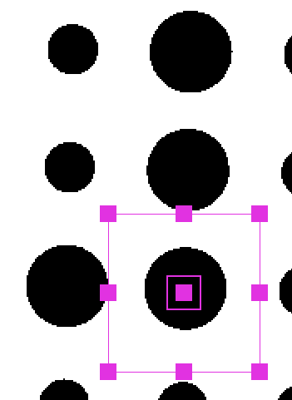

* + 1. Adjust the search window so it is similar to the one shown below
    2. Test this 30 times by hitting SNAP+FIND. Again we don’t care about the values, just that it found it. Do not use continuous S+F

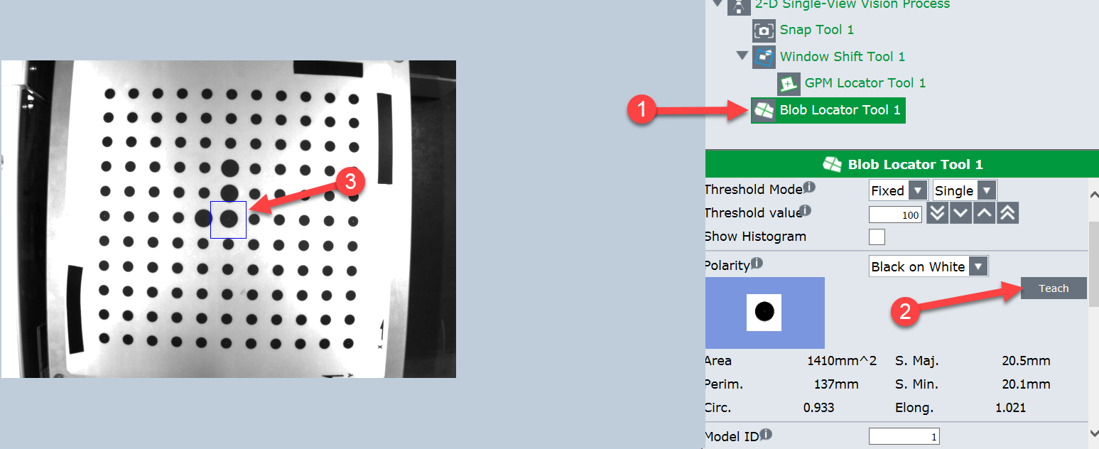

* 1. Select 2-D Single View Vision Process, Snap and find multiple times to make sure everything works correctly

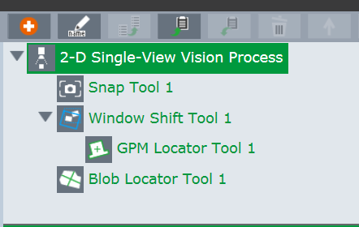

* 1. Click “Set”
  2. These numbers update, they should be pretty close to zero (between -2 and 2). We only care about the X and Y values. We will use these values in “k”
  3. Click “Save”

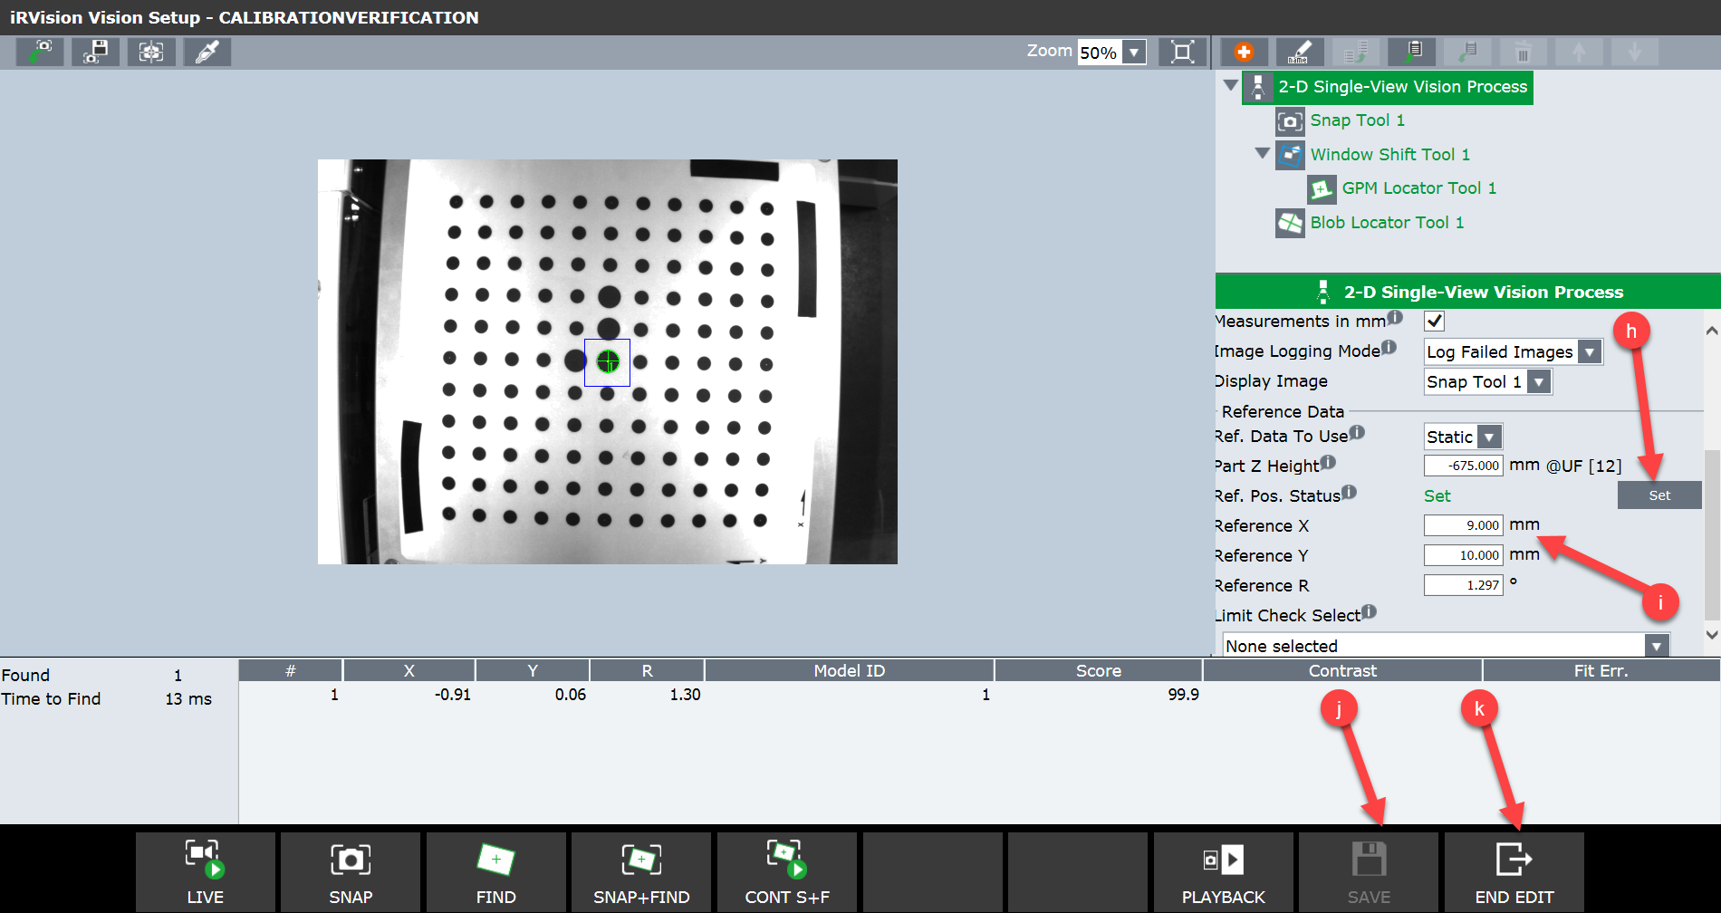

* 1. Take the Refence X and Y from “i” and manually enter them into the robot program CalibrationCheck, lines 11 and 12
  2. Click End Edit in Internet Explorer

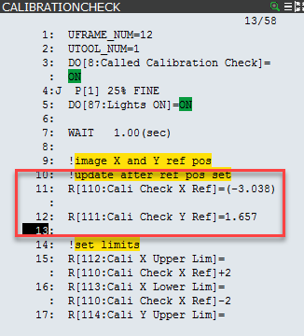

1. Run the CalibrationCheck program multiple times to verify functionality. This program takes the values entered in Step3, sets limits of value +- 10, and verifies once a day that this trained position is within tolerance